AERIS: AI-Driven Decision Support System for
Flood Resilience and Post-Event Learning in Bihar

21CSP302L- PROJECT

Submitted by

Vansh Agrawal [RA2311026010120]
Shivam Rajesh [RA2311026010306]

Under the Guidance of

Dr. Anupama C G

Assistant Professor, Department of Computational Intelligence

in partial fulfillment of the requirements for the degree of

BACHELOR OF TECHNOLOGY

in

COMPUTER SCIENCE ENGINEERING

with specialization in Artificial Intelligence & Machine Learning


DEPARTMENT OF COMPUTATIONAL INTELLIGENCE COLLEGE OF ENGINEERING AND TECHNOLOGY
SRM INSTITUTE OF SCIENCE AND TECHNOLOGY

KATTANKULATHUR- 603 203

MAY 2026


Department of Computational Intelligence

SRM Institute of Science & Technology

Own Work Declaration Form

This sheet must be filled in (each box ticked to show that the condition has been met). It must be signed and dated along with your student registration number and included with all assignments you submit – work will not be marked unless this is done.
To be completed by the student for all assessments

Degree/ Course : B. Tech CSE with Specialization in AI & ML

Student Name : Vansh Agrawal & Shivam Rajesh

Registration Number : RA2311026010120 & RA2311026010306
AERIS: AI-Driven Decision Support System for Flood Resilience and Post-Event Learning in Bihar

Title of Work :

I / We hereby certify that this assessment compiles with the University’s Rules and Regulations relating to Academic misconduct and plagiarism, as listed in the University Website, Regulations, and the Education Committee guidelines.

I / We confirm that all the work contained in this assessment is my / our own except where indicated, and that I / We have met the following conditions:

- Clearly referenced / listed all sources as appropriate
- Referenced and put in inverted commas all quoted text (from books, web, etc)
- Given the sources of all pictures, data etc. that are not my own
- Not made any use of the report(s) or essay(s) of any other student(s) either past or present
- Acknowledged in appropriate places any help that I have received from others (e.g. fellow students, technicians, statisticians, external sources)
DECLARATION:
I am aware of and understand the University’s policy on Academic misconduct and plagiarism and I certify that this assessment is my / our own work, except were indicated by referring, and that I have followed the good academic practices noted above.

Vansh Agrawal Shivam Rajesh

I understand that any false claim for this work will be penalized in accordance with the University policies and regulations.

SRM INSTITUTE OF SCIENCE AND TECHNOLOGY KATTANKULATHUR – 603 203

BONAFIDE CERTIFICATE

Certified that 21CSP302L - Project report titled “AERIS: AI-Driven Decision Support System for Flood Resilience and Post-Event Learning in Bihar” is the Bonafide work of “Vansh Agrawal [RA2311026010120], Shivam Rajesh [RA2311026010306]” who carried out the project work under my supervision. Certified further, that to the best of my knowledge the work reported herein does not form any other project report or dissertation on the basis of which a degree or award was conferred on an earlier occasion on this or any other candidate.

SIGNATURE  Dr. Anupama C G  SUPERVISOR  Assistant Professor  DEPARTMENT OF  COMPUTATIONAL INTELLIGENCE |  | SIGNATURE  DR. R. ANNIE UTHRA  PROFESSOR &HEAD  DEPARTMENT OF  COMPUTATIONAL INTELLIGENCE

EXAMINER 1 EXAMINER 2
Name & Signature Name & Signature
ACKNOWLEDGEMENTS

We express our humble gratitude to Dr. C. Muthamizhchelvan, Vice-Chancellor, SRM Institute of Science and Technology, for the facilities extended for the project work and his continued support.

We extend our sincere thanks to Dr. Leenus Jesu Martin M, Dean-CET, SRM Institute of Science and Technology, for his invaluable support.

We wish to thank Dr. Revathi Venkataraman, Professor and Chairperson, School of Computing, SRM Institute of Science and Technology, for her support throughout the project work.

We encompass our sincere thanks to, Dr. M. Pushpalatha, Professor and Associate Chairperson - CS, School of Computing and Dr.C. Lakshmi, Professor and Associate Chairperson -AI, School of Computing, SRM Institute of Science and Technology, for their invaluable support.

We are incredibly grateful to our Head of the Department, Dr. R Annie Uthra, Head of Department, CINTEl, SRM Institute of Science and Technology, for her suggestions and encouragement at all the stages of the project work.

We want to convey our thanks to our Project Coordinators, Panel Head, and Panel Members Department of Computational Intelligence, SRM Institute of Science and Technology, for their inputs during the project reviews and support.

We register our immeasurable thanks to our Faculty Advisor, Dr. Kiruthika M, Department of CINTEL, SRM Institute of Science and Technology, for leading and helping us to complete our course.

Our inexpressible respect and thanks to our guide, Dr. Anupama CG, Department of External Affairs, SRM Institute of Science and Technology, for providing us with an opportunity to pursue our project under his / her mentorship. She provided us with the freedom and support to explore the research topics of our interest. Her passion for solving problems and making a difference in the world has always been inspiring.

We sincerely thank all the staff members of CINTEL, School of Computing, S.R.M Institute of Science and Technology, for their help during our project. Finally, we would like to thank our parents, family members, and friends for their unconditional love, constant support and encouragement

Vansh Agrawal & Shivam Rajesh
ABSTRACT

Flood disasters in regions like Bihar, India, pose recurring threats to human life, infrastructure, and economic stability. Traditional emergency response systems are predominantly reactive, often resulting in delayed decision-making and suboptimal resource allocation. This aligns with broader observations that conventional systems rely heavily on manual processes and lack real-time situational awareness.

This project introduces AERIS, a predictive, data-driven platform designed to shift flood management from reactive response to proactive preparedness. The use of machine learning, geospatial analytics, and predictive modeling reflects current trends in disaster management systems, where data-driven insights enhance early warning and risk mitigation.

AERIS leverages machine learning, geospatial analytics, and real-time simulation to deliver district-level flood risk predictions and actionable insights. The system’s dual-model architecture combines Logistic Regression for probabilistic flood forecasting with XGBoost to analyze embankment breach risks. Such predictive AI models are widely recognized for improving disaster forecasting accuracy and enabling proactive interventions. A 7-day forecasting simulator facilitates scenario-based analysis by dynamically adjusting environmental variables such as rainfall and river water levels.

Key features of the platform include interactive GIS-based visualizations, real-time telemetry simulation, and resilience scoring, all aimed at empowering decision-makers in emergency planning and resource management. The integration of geospatial data and AI-driven decision support systems enhances situational awareness and resource optimization during disasters.

Experimental evaluation demonstrates high predictive accuracy and effective visualization of flood risk patterns. By enhancing early warning capabilities, optimizing resource deployment, and strengthening preparedness strategies, AERIS represents a significant advancement in disaster management and flood resilience.

Keywords: AI-Driven Disaster Management, Flood Risk Prediction, Machine Learning, Logistic Regression, XGBoost, Geospatial Analytics, GIS Visualization, Real-Time Simulation, Decision Support Systems, Early Warning Systems, Disaster Preparedness, Resource Optimization, Flood Resilience, Predictive Analytics, Embankment Risk Analysis.

TABLE OF CONTENTS
ABSTRACT v

TABLE OF CONTENTS vi

LIST OF FIGURES x

LIST OF TABLES xi

ABBREVIATIONS xii

CHAPTER TITLE PAGE
NO. NO.

- INTRODUCTION 1
  - Introduction to Project 1
  - Problem Statement 1
  - Motivation 2
1.4 Sustainable Development Goal of the Project 2

2 LITERATURE SURVEY 3
2.1 Overview of the Research Area 3
2.2 Machine Learning Approaches 5
2.3 Deep Learning Approaches 5
2.4 Geo-Spatial and Spatio-Temporal Modeling 6
2.5 Hybrid and Integrated Systems 6
2.6 Challenges and Research Gaps 6
2.7 Summary 7

3 SPRINT PLANNING AND EXECUTION METHODOLOGY 8
3.1 Sprint I : Data Processing, Model Development and Backend APIs 8
3.1.1 Objective with User Stories of Sprint I 8
3.1.2 Functional Document 9
3.1.3 Architecture Document 9
3.1.4 Outcome of Objectives / Result Analysis 10
3.1.5 Sprint Retrospective 10
3.2 Sprint II – Frontend Dashboard, GIS Mapping and Simulation Engine 10
3.2.1 Objectives with User Stories of Sprint II 10
3.2.2 Functional Document 11
3.2.3 Architecture Document 11
3.2.4 Outcome of Objectives / Result Analysis 12
3.2.5 Sprint Retrospective 12
3.3 Sprint Review and Testing 12
3.4 Final Sprint Outcome 12
3.5 Sprint Summary Table 13

4 SYSTEM DESIGN AND METHODOLOGY 14
4.1 Introduction 14
4.2 Overall System Architecture 14
4.3 Module Description 14
4.3.1 Frontend Layer 14
4.3.2 Backend Layer 15
4.3.3 Machine Learning Layer 15
4.3.4 GIS Layer 15
4.4 Data Flow Diagram 16
4.5 Machine Learning Methodology 16
4.5.1 Logistic Regression Model 16
4.5.2 XGBoost Model 17
4.6 Dataset Design 18
4.6.1 Bihar Flood Dataset 18
4.6.2 Support Dataset 18
4.7 Database Design 18
4.8 User Interface Design 19
4.9 Security Considerations 19
4.10 Advantages of System Design 19

5 IMPLEMENTATION AND TESTING 20
5.1 Introduction 20
5.2 Frontend Implementation 20
5.3 Routing Implementation 21
5.4 Major Page Implementation 21
5.4.1 Live Risk Map 21
5.4.2 Forecast Simulator 21
5.4.3 Predictor Page 21
5.4.4 Telemetry Page 22
5.5 Backend Implementation 22
5.6 API Endpoints 23
5.7 API Working Flow 23
5.7.1 Initialization Phase (System Boot) 23
5.7.2 Core Prediction Workflow (/predict) 23
5.7.3 Monitoring & Telemetry Flow (/telemetry/realtime) 24
5.7.4 Supporting Intelligence Flows 24
5.8 Testing Methodology 26
5.8.1 Unit Testing 26
5.8.2 Functional Testing 26
5.8.3 Integration Testing 26
5.8.4 Performance Testing 26
5.9 Error Handling 27
5.10 Screenshots to Insert 27
5.11 Implementation Outcome 29
5.12 Summary 30

6 RESULTS AND DISCUSSIONS 31
6.1 Introduction 31
6.2 Model Performance Evaluation 31
6.2.1 Comparative Performance Table 31
6.2.2 Logistic Regression Model Analysis 32
6.2.3 XGBoost Breach Predictor Analysis 32
6.2.4 XGBoost Flood Forecaster 32
6.3 User Interface Output Results 33
6.3.1 Live Risk Map 33
6.3.2 River Pulse Monitoring Panel 34
6.3.3 Forecast Simulator 34
6.3.4 Predictor Page 35
6.3.5 Resilience Scorecard 35
6.4 Comparative Analysis with Traditional Systems 36
6.5 Discussion of Findings 36
6.6 Limitations of Results 39
6.7 Summary 39

7 CONCLUSION AND FUTURE ENHANCEMENT 40
7.1 Introduction 40
7.2 Conclusion 40
7.3 Achievement of Objectives 40
7.4 Future Enhancements 41
7.5 Final Remarks 41

REFERENCES 42

APPENDIX A 43
A CODING 43

B CONFERENCE JOURNAL PUBLICATION 46

C PLAGIARISM REPORT 47

LIST OF FIGURES

CHAPTER TITLE PAGE
NO. NO.

4.1 Overall System Architecture 14

4.2 Data Flow Diagram 16

5.1 Project Structure 20

5.2 Api Working Flow 25

5.10.1 Forecast Simulator 27

5.10.2 Hime Forensic Map 28

5.10.3 Resilience Scorecard 28

5.10.4 Post Mortem Analysis 29

5.10.5 River Pulse Monitor 29

A.A.1 Feature Correlation Matrix 30

A.A.2 Receiver Operating Characteristic (ROC) 43

A.A.3 AERIS Architecture Performance Benchmarks 44

A.A.4 Feature Importance for Flood Prediction 44

A.A.5 Monsoon Seasonality: Rainfall vs. Flood Occurrences 44

A.A.6 Post-Event Reslience Scorecard 45

A.A.7 Precision-Recall Curve for Flood Prediction 45

A.A.8 Top 10 Most Vulnerable Districts in Bihar 46

B.1 Coding Workspace 55

C.1 Public Notification 56

D.1 Plagiarism Report 57

LIST OF TABLES

CHAPTER TITLE PAGE
NO. NO.

2.1 Research Area 16

3.1.1 Sprint Summary Table 16

3.1.2 Sprint 2 22

4.1 Bihar Flood Dataset 19

4.2 Support Dataset 19

5.1 Routes 24

5.2 API Endpoints 26

5.3 Unit Testing 29

5.4 Functional Testing 29

5.5 Performance Testing 30

6.2.1 Comparative Performance Table 34

6.2.1 Threshold Classification 35

6.3.3 Forest Test Cases 37

6.4 Comparative Analysis with Traditional Systems 39

7.1 Achievement of Objectives 40

ABBREVIATIONS

AI Artificial Intelligence
ML Machine Learning
DL Deep Learning
GIS Geographic Information System
IoT Internet of Things
API Application Programming Interface
JSON JavaScript Object Notation
UI User Interface
LR Logistic Regression
XGBoost Extreme Gradient Boosting
CNN Convolutional Neural Network
LSTM Long Short-Term Memory
CSV Comma Separated Values
DB Database
HTTP Hyper Text Transfer Protocol
HTML Hyper Text Markup Language
CSS Cascading Style Sheets
JS JavaScript
ROC Receiver Operating Characteristic
AUC Area Under Curve
F1 Score Harmonic Mean of Precision and Recall
SHAP SHapley Additive exPlanations
LIME Local Interpretable Model-Agnostic Explanations
SDG Sustainable Development Goals

CHAPTER 1
INTRODUCTION

  - Introduction to Project
Flooding is one of the most frequent and devastating natural disasters, impacting millions of people each year, especially in vulnerable regions like North Bihar. Factors such as climate change intensification, high population density, and inadequate infrastructure have exacerbated the severity and consequences of floods. Traditional flood management approaches primarily depend on manual monitoring and reactive responses, which often result in delayed decision-making and increased damage.
The AERIS system seeks to overcome these challenges by harnessing artificial intelligence and data-driven techniques. By combining advanced machine learning models with geospatial visualization and simulation tools, AERIS enables proactive flood management. The platform delivers early warnings, comprehensive risk assessments, and actionable insights, empowering authorities to take timely and effective measures to mitigate disaster impact before it escalates.

  - Problem Statement
Current disaster management systems face three key challenges:
- They often lack reliable and timely ways to predict disasters early.
- They rely heavily on manual processes, which can slow down response times.
- They don’t have unified platforms that bring together data, predictions, and visual tools to support decision-making.
Because of these gaps, emergency responses can be less effective, sometimes resulting in more harm and wasted resources. What’s really needed is a smart system that can accurately forecast flood risks, model different future scenarios, and help authorities make informed, data-driven choices to protect people and resources better.

  - Motivation
The motivation behind AERIS comes from the frequent flood crises in Bihar, where delays in response and insufficient preparedness often lead to serious loss of life and property. Current solutions tend to be either too general or don’t address the specific needs of the region.
This project seeks to close the gap between predicting floods and taking effective action. It aims to create a system that not only forecasts flood risks but also offers clear insights and practical planning tools. The ultimate goal is to equip decision-makers with trustworthy, real-time information to help them respond swiftly and effectively.

  - Sustainable Development Goal
This project supports the United Nations Sustainable Development Goals 11 (Sustainable Cities and Communities) and 13 (Climate Action). By improving disaster preparedness and lowering risks through advanced predictive intelligence, AERIS helps create more resilient infrastructure and promotes sustainable urban planning, making communities safer and better equipped to face climate challenges.

CHAPTER 2
LITERATURE SURVEY
2.1 Overview of the Research Area
Flood disaster management has become a critical research area due to increasing climate change impacts, rapid urbanization, and the vulnerability of infrastructure and populations in flood-prone regions. Floods cause severe damage to human life, economy, and essential services, particularly in developing regions where preparedness and response systems are limited. Accurate flood prediction and efficient emergency response systems are therefore essential for minimizing losses and improving resilience.
However, flood prediction is inherently complex due to nonlinear relationships between environmental factors such as rainfall, river discharge, soil conditions, and topography. Additionally, strong spatio-temporal dependencies and data uncertainty further complicate modeling. Traditional statistical approaches often fail to capture these complexities effectively, leading researchers to adopt Artificial Intelligence (AI)-based methods, particularly Machine Learning (ML) and Deep Learning (DL), for improved prediction accuracy and decision-making.
Recent studies demonstrate that AI-driven systems enhance disaster management by enabling predictive analytics, real-time monitoring, and automated decision support. These systems integrate multiple data sources such as IoT sensors, satellite imagery, and geospatial datasets to improve situational awareness. Despite these advancements, many systems remain simulation-based, lack real-world deployment, and fail to integrate prediction with response mechanisms.

Table 2.1 Research Area
Author (Year) & Journal | Methodology | Advantages | Limitations
Bajwa (2025) | AI + IoT + Predictive Analytics | Enables real-time monitoring and improves decision-making efficiency | Limited real-world deployment and interoperability issues
Khan et al. (2023) | GIS + Machine Learning + Remote Sensing | Enhances spatial flood prediction and risk assessment | Highly dependent on high-quality geospatial data
Tonwe (2025) | Reinforcement Learning for dispatch systems | Optimizes emergency response and resource allocation | Focused only on response, not prediction
Ghaffarian et al. (2023) | Explainable AI (XAI) models | Improves transparency and trust in decision-making | Limited integration in real-time systems
Albahri et al. (2024) | ML/DL + Data Fusion + Prediction Models | Enables early warning systems and predictive disaster management | Issues related to bias, trust, and interpretability

2.2 Machine Learning Approaches
Machine learning models have been widely adopted for flood prediction due to their ability to model nonlinear relationships and process structured environmental data. Algorithms such as Random Forest (RF), Support Vector Machines (SVM), and Logistic Regression are commonly used in flood risk prediction. These models provide strong baseline performance, are computationally efficient, and can handle large datasets effectively.
Gradient boosting techniques such as Extreme Gradient Boosting (XGBoost) have demonstrated superior predictive performance by iteratively minimizing prediction errors. These models are particularly effective in capturing complex nonlinear interactions among environmental variables. However, machine learning models generally require extensive feature engineering and are limited in capturing temporal dependencies unless additional preprocessing techniques are applied.

2.3 Deep Learning Approaches
Deep learning techniques have gained significant attention for flood prediction due to their ability to learn complex feature representations from large-scale data.

2.3.1 LSTM-Based Models
Long Short-Term Memory (LSTM) networks are widely used for time-series forecasting because they effectively capture long-term dependencies in sequential data. These models are particularly useful for modeling rainfall patterns, river flow variations, and seasonal flood trends. However, LSTM models require large datasets and high computational resources, which can limit their practical applicability.

2.3.2 CNN-Based Models
Convolutional Neural Networks (CNNs) are used to extract spatial features from geospatial and satellite data. Hybrid CNN-LSTM models combine spatial and temporal learning, improving prediction accuracy. However, CNN-based models depend on structured spatial data and may not perform well in regions with limited data availability.

2.3.3 Attention-Based Models
Attention mechanisms have been introduced to improve sequence modeling by focusing on relevant temporal features. These models enhance prediction accuracy by reducing error propagation in long-term forecasting. Despite their advantages, they increase computational complexity and require careful parameter tuning.

2.4 Geospatial and Spatio-Temporal Modeling
Flood prediction exhibits strong spatial and temporal dependencies, making geospatial modeling essential. Integration of AI with Geographic Information Systems (GIS) enables spatial risk mapping and vulnerability assessment. These models use satellite imagery, remote sensing data, and environmental variables to generate flood susceptibility maps.
While these approaches improve prediction accuracy and spatial understanding, most systems focus primarily on risk assessment and lack real-time response capabilities. Additionally, they depend heavily on high-quality geospatial datasets, which limits their usability in developing regions.

2.5 Hybrid and Integrated Systems
To overcome the limitations of individual models, hybrid approaches combining machine learning, deep learning, and geospatial analysis have been proposed. These systems aim to integrate prediction, simulation, and decision-making into a unified framework.
Recent research also explores the integration of IoT-based real-time data processing with AI models to enable dynamic monitoring and early warning systems. These hybrid systems improve situational awareness and response coordination. However, they face challenges related to infrastructure dependency, data reliability, and scalability.

2.6 Challenges and Research Gaps
Despite significant advancements, several challenges remain in AI-based flood disaster management. Data quality issues such as missing or noisy environmental data significantly affect model performance. Model generalization remains a major concern, as models trained in one region may not perform well in different geographical conditions.
Additionally, deep learning and hybrid models require high computational resources, making them difficult to deploy in real-time systems. Many models lack interpretability, functioning as black-box systems, which reduces trust and usability in critical decision-making scenarios. Furthermore, most existing systems fail to integrate prediction, simulation, and response into a single framework, resulting in fragmented solutions.

2.7 Summary
The literature indicates a clear shift from traditional statistical methods to advanced AI-based approaches for flood prediction and disaster management. Machine learning models provide strong baseline performance, while deep learning models effectively capture spatio-temporal dependencies. Hybrid systems integrating multiple techniques offer improved accuracy and functionality.
However, there is still a need for a unified system that balances prediction accuracy, real-time decision-making, interpretability, and scalability. This motivates the development of integrated frameworks such as AERIS, which aim to combine machine learning, geospatial intelligence, and real-time simulation into a comprehensive disaster management solution.

CHAPTER 3
SPRINT PLANNING AND EXECUTION METHODOLOGY

The development of the AERIS(AI-Enhanced Risk Intelligence System) was carried out using the Agile Scrum methodology, which emphasizes iterative development, continuous feedback, and incremental feature delivery. The project was divided into three well-defined sprints, each focusing on specific objectives such as data acquisition, system enhancement, and predictive analytics.

The AERIS project was executed in two main sprints, each lasting around 2 to 3 weeks.

3.1 SPRINT I: DATA PROCESSING, MODEL DEVELOPMENT AND BACKEND APIs

3.1.1 Objectives with User Stories of Sprint I

ID | USER STORY | OBJECTIVE
1 | As a data engineer, I want to collect and preprocess flood datasets so that models can be trained effectively | Data acquisition & preprocessing
2 | As an AI developer, I want to build ML models for flood prediction so that risk can be estimated accurately | Model development
3 | As a backend developer, I want APIs for model access so that frontend can fetch predictions | Backend API integration
Table 3.1.1 sprint 1

3.1.2 Functional Document
The functional implementation of Sprint I focused on building the core analytical engine:
- Data Acquisition
Collected district-level flood datasets including rainfall, river levels, soil moisture, elevation, and historical flood records.
- Data Preprocessing
  - Missing value removal
  - Feature normalization
  - Encoding categorical data
  - Dataset splitting
- Logistic Regression Model
  - Binary classification (Flood / No Flood)
  - Output: Probability score (0–100%)
  - Accuracy: ~94%
- XGBoost Model
  - Predict embankment breach risk
  - Output: High / Medium / Low classification
- Backend Development (FastAPI)
APIs developed:
  - /predict-flood
  - /predict-breach
  - /simulate-forecast
  - /district-data

3.1.3 Architecture Document
The architecture followed a modular ML-backend pipeline:
- Data Layer → Preprocessed datasets
- ML Layer → Logistic Regression + XGBoost
- Backend Layer → FastAPI server
- API Interface → REST endpoints
Data Flow:
Dataset → Preprocessing → Model Training → API Integration → Prediction Output

3.1.4 Outcome of Objectives / Result Analysis
- Successful development of high-accuracy prediction models (~94%)
- Backend APIs fully functional and integrated
- Reliable prediction pipeline established
- Foundation for simulation and frontend integration completed

3.1.5 Sprint Retrospective
What Went Well:
- Accurate ML model development
- Efficient API implementation
- Successful data preprocessing
Areas for Improvement:
- Limited real-world dataset availability
- Initial model overfitting
- Feature correlation challenges

3.2 SPRINT II: FRONTEND DASHBOARD, GIS MAPPING AND SIMULATION ENGINE

3.2.1 Objectives with User Stories of Sprint II
ID | USER STORY | OBJECTIVE
1 | As a user, I want a dashboard to visualize flood risk so that I can make decisions quickly | UI Dashboard
2 | As an authority, I want GIS maps showing district risk so that vulnerable areas can be identified | GIS visualization
3 | As a planner, I want a simulation tool so that future flood scenarios can be analyzed | Forecast simulator
Table 3.1.2 sprint 2

3.2.2 Functional Document
- Frontend Development (React.js)
Pages developed:
  - Dashboard
  - Risk Panel
  - Forecast Simulator
  - River Monitoring
  - Resilience Scorecard
- GIS Mapping Module
  - District-wise risk visualization
  - Color-coded risk (Red / Orange / Green)
  - Interactive map controls
- 7-Day Forecast Simulator
Adjustable parameters:
  - Rainfall
  - River level
  - Drainage capacity
  - Embankment condition
- River Telemetry Module
  - Real-time water level simulation
  - Threshold alerts
- Resilience Scorecard
Based on infrastructure, population, healthcare, and historical risk

3.2.3 Architecture Document
Enhanced architecture with frontend integration:
- Frontend Layer → React Dashboard
- Backend Layer → FastAPI APIs
- ML Layer → Prediction models
- GIS Layer → GeoJSON + mapping engine
Data Flow:
User Input → Frontend → API Call → ML Prediction → Response → Visualization

3.2.4 Outcome of Objectives / Result Analysis
- Fully functional interactive dashboard
- Real-time GIS-based visualization implemented
- Scenario simulation engine operational
- Complete frontend-backend integration achieved

3.2.5 Sprint Retrospective
What Went Well:
- Smooth frontend-backend integration
- Effective GIS visualization
- Functional simulation engine
Areas for Improvement:
- API latency during simulation
- Large data rendering issues
- UI responsiveness optimization

3.3 SPRINT REVIEW AND TESTING
Testing included:
- Functional Testing → UI & API validation
- Model Testing → Accuracy & consistency
- Integration Testing → Frontend-backend communication
- Performance Testing → Load and response time

3.4 FINAL SPRINT OUTCOME
The sprint-based development successfully delivered:
- Accurate flood prediction system
- Embankment risk detection
- GIS-based visualization
- Forecast simulation engine
- Resilience scoring system
This validates the effectiveness of Agile methodology in building AERIS.

3.5 SPRINT SUMMARY TABLE
Sprint | Duration | Modules Completed
Sprint I | 2 Weeks | ML Models, APIs, Data Processing
Sprint II | 2 Weeks | Frontend, GIS Map, Simulator

CHAPTER 4
SYSTEM DESIGN AND METHODOLOGY

4.1 Introduction
The AERIS (AI-Enhanced Risk Intelligence System) platform is designed as a modern full-stack intelligent disaster management system for flood-prone regions of Bihar. The system combines machine learning, geospatial intelligence, interactive dashboards, and forecasting simulation into one unified decision-support platform.
The architecture of AERIS is modular and scalable. It consists of four major layers:
  - Frontend Presentation Layer
  - Backend API Layer
  - Machine Learning Inference Layer
  - Geospatial Data Layer
This layered design ensures easy maintenance, fast processing, and future scalability.
4.2 Overall System Architecture
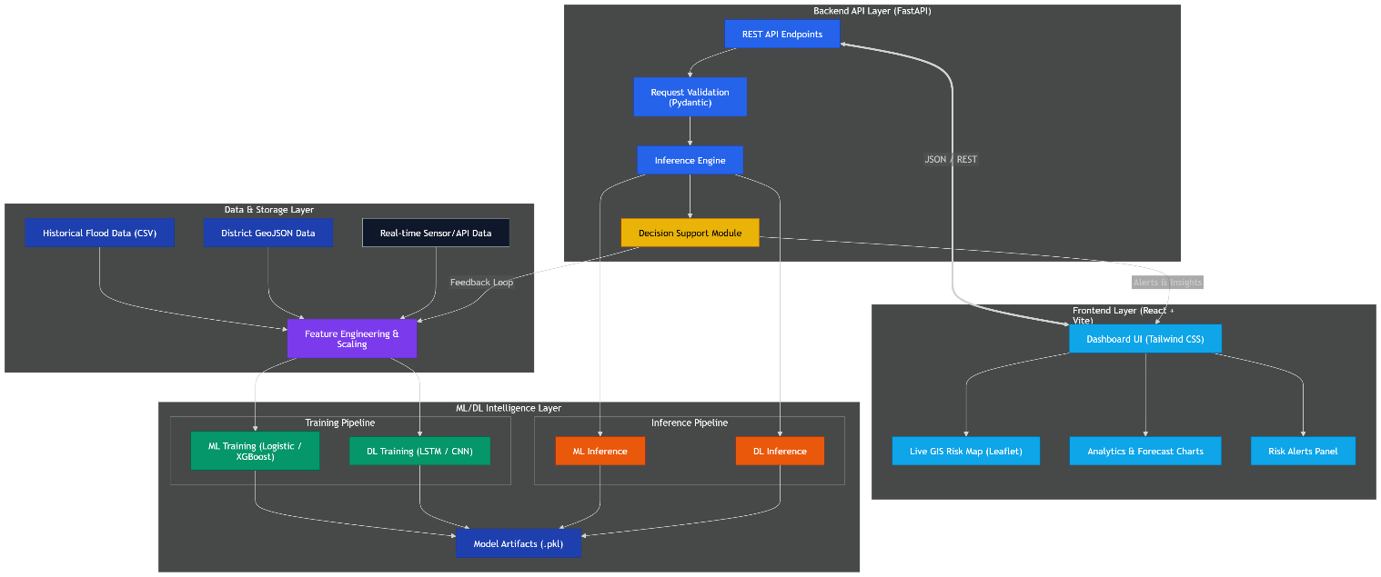
Fig. 4.1 Overall System Architecture
4.3 Module Description
4.3.1 Frontend Layer
The frontend is responsible for user interaction and data visualization.
Technologies used:
  - React 19
  - Vite
  - Tailwind CSS
  - Framer Motion

Functions:
  - Interactive dashboard
  - District risk maps
  - Forecast charts
  - Prediction forms
  - Monitoring panels

4.3.2 Backend Layer
The backend server was developed using FastAPI.
Responsibilities:
  - API request handling
  - Data validation
  - Calling ML models
  - Returning JSON responses
  - Real-time simulation generation

Advantages of FastAPI:
  - High speed
  - Lightweight
  - Easy integration with Python ML models
  - Auto-generated API docs

4.3.3 Machine Learning Layer
This is the intelligence core of AERIS.
Two model families are used:
Logistic Regression
Used for district flood probability prediction.
XGBoost
Used for:
  - Embankment breach probability
  - Flood severity forecast

4.3.4 GIS Layer
Used for district-level flood visualization.
Technologies:
  - React Leaflet
  - GeoJSON maps

Displays:
  - Risk zones
  - District boundaries
  - Color-coded vulnerability levels

4.4 Data Flow Diagram
The operational flow of the system is as follows:
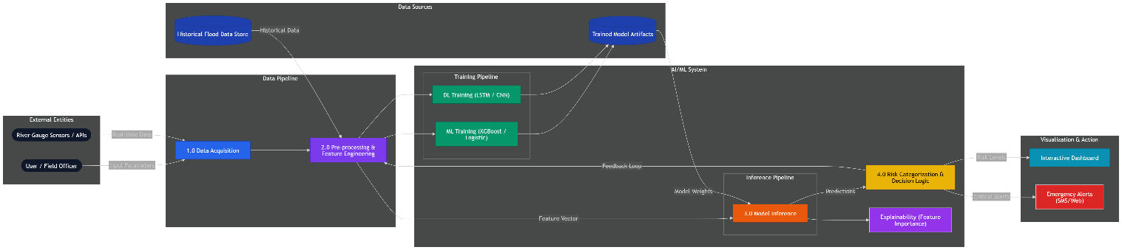
Fig. 4.2 Data Flow Diagram
4.5 Machine Learning Methodology
4.5.1 Logistic Regression Model
The Logistic Regression model predicts whether a flood event is likely in a district.
Input Features:
  - Rainfall (mm)
  - River Level (m)
  - Danger Level
  - Population
  - Crop Area
  - Month
  - Day
  - District dummy variables

Output:
  - Probability Score (%)
  - Risk Status (Green / Orange / Red)

Formula:
P(Y=1) = 1 / (1 + e^-(β0 + β1x1 + β2x2 + ... + βnxn))
Performance:
  - Accuracy = 94.73%
  - F1 Score = 0.8451

4.5.2 XGBoost Model
XGBoost was selected because it handles non-linear relationships better.
Used For:
  - Embankment Breach Prediction
  - Flood Severity Forecasting

Features:
  - Embankment Age
  - Maintenance Score
  - Rainfall
  - Vulnerability Score

Benefits:
  - High accuracy
  - Fast prediction
  - Feature importance analysis

4.6 Dataset Design
Two datasets were used.
4.6.1 Bihar Flood Dataset
Column | Description
Date | Observation Date
District | Bihar District
Rainfall_mm | Daily Rainfall
River_Level_m | River Level
Population | Population
Crop_Area_ha | Crop Area
Flood | Target Variable

Table 4.1 Bihar Flood Dataset
4.6.2 Support Dataset
Column | Description
embankment_age | Structure age
maintenance_score | Upkeep rating
rainfall_mm | Rainfall
vuln_score | Vulnerability index
embankment_breach | Label

Table 4.2 Support Dataset
4.7 Database Design
AERIS uses lightweight CSV file storage.
Advantages:
  - Easy maintenance
  - Suitable for research project
  - No server DB dependency
  - Fast local access

Future upgrades can use PostgreSQL or MongoDB.
4.8 User Interface Design
The platform contains seven functional pages.
- Live Risk Map
District risk GIS map.
- Forecast Timeline
7-day probability chart.
- Predictor Page
Manual flood scenario testing.
- Telemetry Page
18 river station live monitoring.
- Resilience Scorecard
Preparedness ranking.
- Post-Mortem
Historical flood forensic analysis.
- Research Review
Technical system documentation.
4.9 Security Considerations
  - Input validation using Pydantic
  - Controlled API routes
  - Safe JSON communication
  - Error handling mechanisms

4.10 Advantages of System Design
  - Modular architecture
  - Easy scalability
  - Real-time decision support
  - Explainable AI models
  - GIS intelligence integration

CHAPTER 5
IMPLEMENTATION AND TESTING

5.1 Introduction
After system design, AERIS was implemented as a functional prototype integrating frontend dashboards, backend APIs, and trained machine learning models.
The implementation focused on performance, usability, and reliability.

5.2 Frontend Implementation
The frontend was built using React.js.
Project Structure:
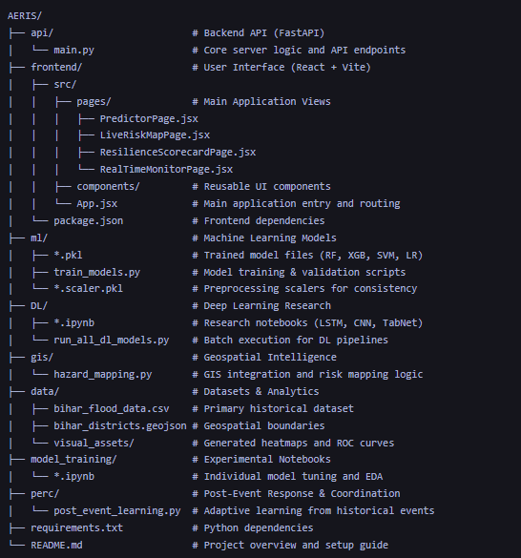

Fig 5.1 Project Structure

5.3 Routing Implementation
React Router was used.
Routes:
Path | Page
/ | Live Risk Map
/forecast | Forecast Page
/predictor | Predictor
/telemetry | River Pulse
/scorecard | Scorecard

Table 5.1 Routes
5.4 Major Page Implementation
5.4.1 Live Risk Map
Features:
  - Bihar district polygons
  - Risk colors
  - Situation room panel
  - Hover analytics

    - Forecast Simulator
User inputs:
  - Rainfall
  - Vulnerability Score

Outputs:
  - 7-day trend chart
  - Alert status

    - Predictor Page
Manual fields:
  - District
  - Rainfall
  - River Level
  - Population

Displays:
  - Probability gauge
  - Status badge
  - Model metrics

    - Telemetry Page
Displays 18 stations across:
  - Kosi
  - Gandak
  - Bagmati
  - Mahananda
  - Sone

Each card shows:
  - Current Level
  - Trend Arrow
  - Breach Risk
  - Flood Risk

  - Backend Implementation
FastAPI backend developed in Python.
Startup Logic:
  - app = FastAPI()
  - load_models()

Models Loaded:
  - lr_model.pkl
  - lr_scaler.pkl
  - breach_xgb.pkl
  - flood_prob.pkl

  - API Endpoints
Method | Endpoint | Purpose
GET | / | Health Check
POST | /predict | Flood Prediction
POST | /predict/breach | Breach Prediction
POST | /predict/7day_forecast | Future Forecast
GET | /telemetry/realtime | Station Data

Table 5.2 API Endpoints

5.7 API Working Flow
The API is built using FastAPI (Python) and follows a modular workflow:

5.7.1 Initialization Phase (System Boot)
Before the API accepts requests, it performs the following setup:
- Model Loading: Deserializes and loads three core models into memory:
  - Logistic Regression (LR): Primary flood classifier.
  - XGBoost Breach: Specialized for embankment failure prediction.
  - XGBoost Flood Prob: Support model for secondary validation.
- Feature Scaler: Loads lr_scaler.pkl to ensure incoming data is normalized exactly like the training set.
- Static Data Loading: Loads district-specific vulnerability profiles from flood_data.csv to provide context for predictions.

5.7.2 Core Prediction Workflow (/predict)
This is the most critical flow in the system:
- Request Capture: Receives a JSON payload containing Rainfall, River Levels, Population, and District info.
- Dynamic Feature Engineering:
  - Maps the input District to its corresponding one-hot encoded column (43 features total).
  - Combines temporal data (Year/Month/Day) with environmental metrics.
- Normalization: The 43-feature vector is passed through the LR_SCALER.
- Inference: The LR_MODEL calculates the probability of a flood event.
- Alert Classification:
  - > 75%: RED (Critical Alert)
  - > 40%: ORANGE (High Risk)
  - < 40%: NORMAL (Safe)
- Response: Returns the probability, alert status, and model accuracy metadata to the frontend.

5.7.3 Monitoring & Telemetry Flow (/telemetry/realtime)
Used to power the Live Risk Map:
- Station Mapping: Fetches coordinates and base hydrological data for 18 major river gauge stations (e.g., Birpur, Baltara).
- Real-time Simulation:
  - Calculates a "current level" by combining base water levels with ML-predicted breach and flood probabilities.
- Trend Analysis: Compares current levels with previous readings to determine if water is Rising, Falling, or Steady.
- Map Integration: Sends geographic data to the frontend for rendering heatmaps and marker status.

5.7.4 Supporting Intelligence Flows
- /predict/breach: Analyzes embankment_age and maintenance_score via the XGBoost model to predict structural failures.
- /predict/7day_forecast: Uses a cumulative normal distribution simulation seeded by current rainfall to project risk trajectories for the coming week.
- /system/info: Auto-detects the server's local network IP to facilitate seamless mobile device testing (via QR codes).

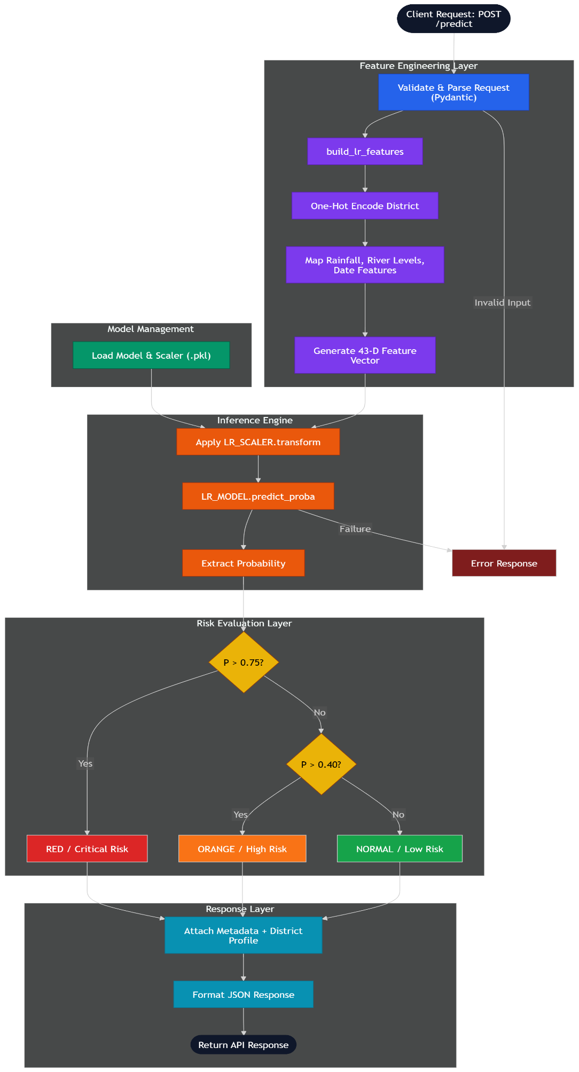
Fig 5.2 Api Working Flow
5.8 Testing Methodology
To ensure reliability, four types of testing were conducted.

5.8.1 Unit Testing
Tested individual modules.
Examples:
Test Case | Result
Feature Builder | Pass
Model Prediction | Pass
Threshold Logic | Pass

Table 5.3 Unit Testing

5.8.2 Functional Testing
Verified complete endpoints.
Endpoint | Result
/predict | Pass
/predict/breach | Pass
/forecast | Pass
/telemetry | Pass

Table 5.4 Functional Testing

5.8.3 Integration Testing
Validated frontend + backend communication.
Scenarios tested:
  - Predictor page calls API
  - Telemetry loads live data
  - Forecast updates chart

All successful.

5.8.4 Performance Testing
Parameter | Result
API Response Time | <1 sec
Dashboard Load Time | <2 sec
Prediction Speed | Instant

Table 5.5 Performance Testing

  - Error Handling

Implemented:
  - Invalid input messages
  - Missing field validation
  - Network error fallback
  - Retry mechanism

5.10 Screenshots
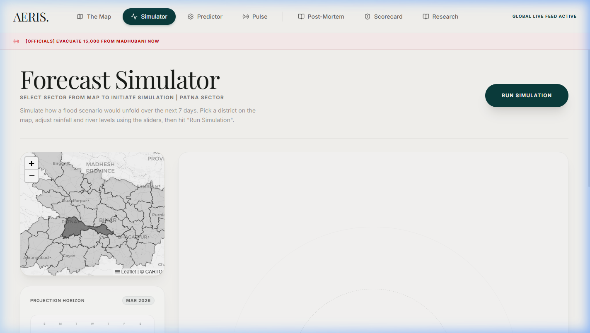
Fig. 5.10.1 Forecast Simulator

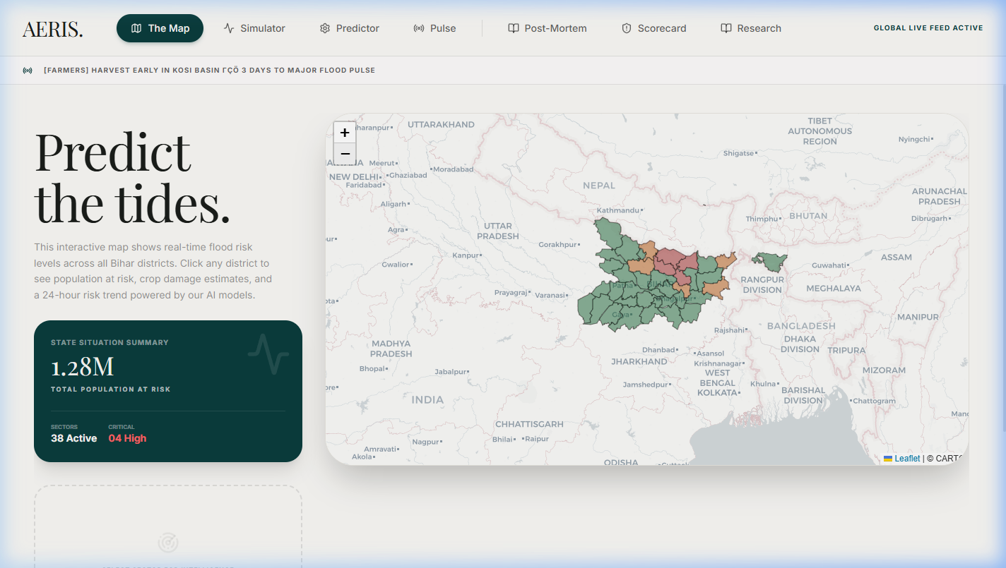
Fig. 5.10.2 Home Forensic Map

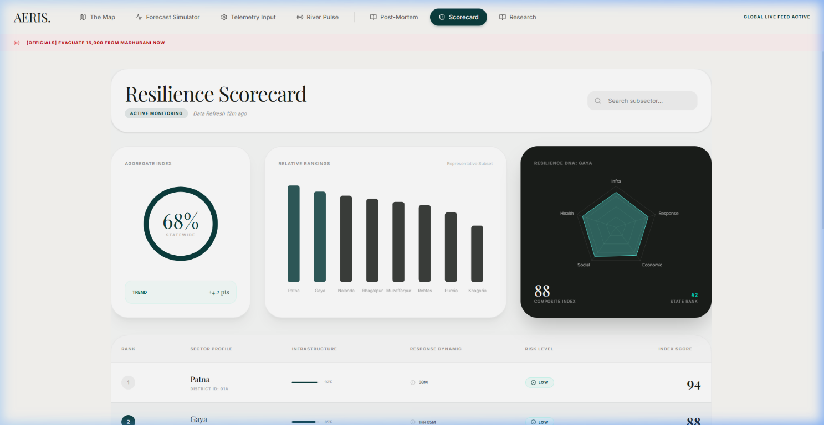
Fig. 5.10.3 Resilience Scorecard

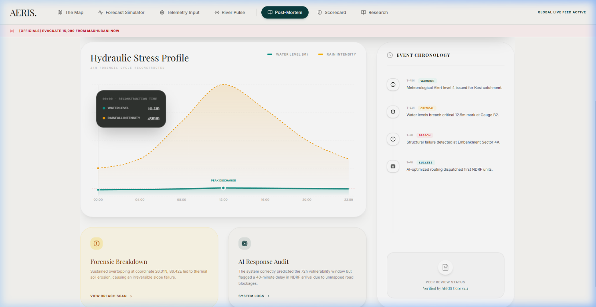
Fig. 5.10.4 Post Mortem Analysis
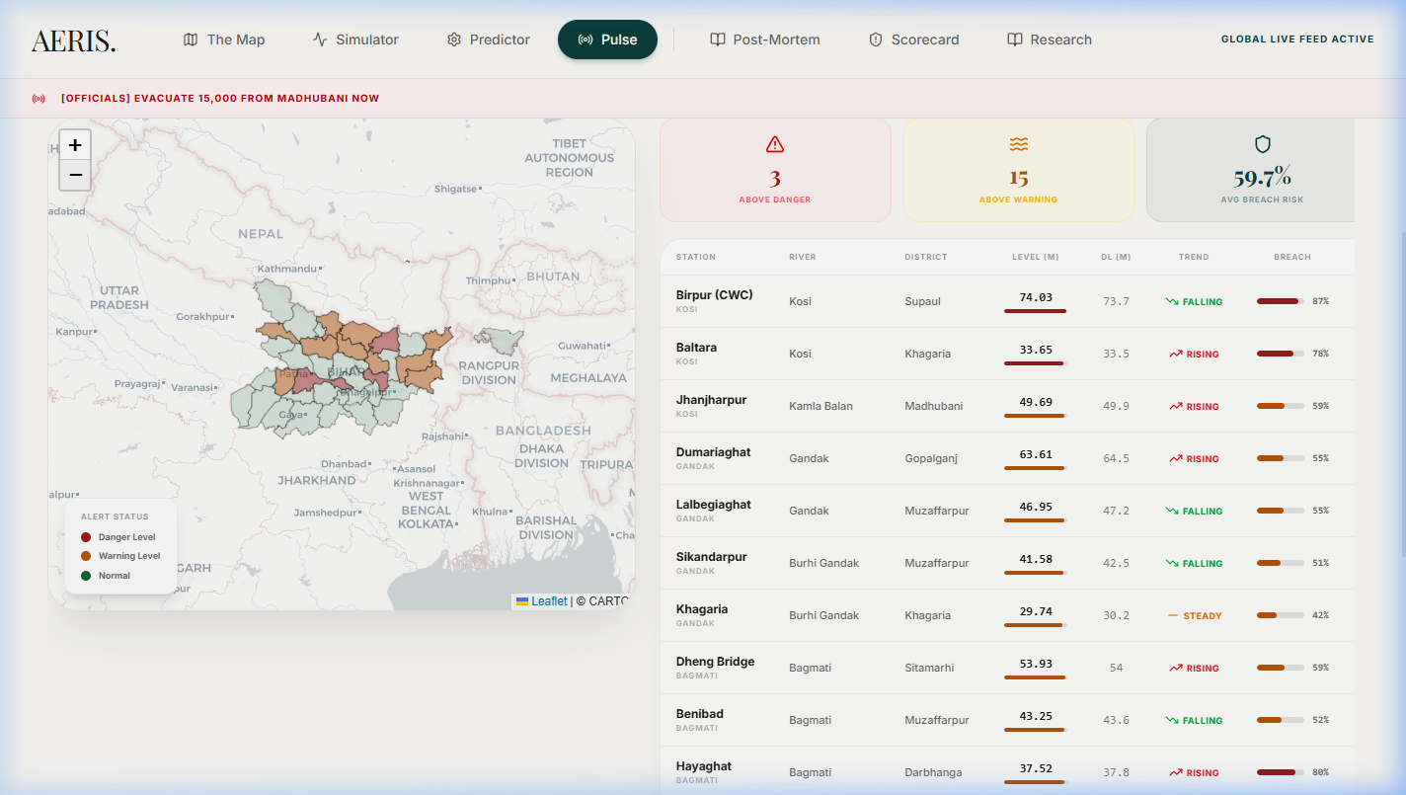
Fig. 5.10.5 River Pulse Monitor
  - Implementation Outcome
The system was successfully implemented with all modules functioning correctly.
Final Deliverables:
  - Smart Dashboard
  - Prediction Engine
  - GIS Risk Map
  - Telemetry System
  - Forecast Simulator
  - Resilience Scorecard

  - Summary
The implementation phase transformed the designed architecture into a fully functional disaster management platform. Testing results confirmed system reliability, responsiveness, and prediction efficiency.

CHAPTER 6
RESULTS AND DISCUSSION

6.1 Introduction
The AERIS (AI-Enhanced Risk Intelligence System) platform was developed to evaluate the effectiveness of Artificial Intelligence, geospatial visualization, and real-time simulation in improving flood disaster management. This chapter presents the experimental outcomes, system performance metrics, interface results, comparative analysis, and discussion of findings.
The system was tested as an integrated prototype consisting of:
  - Logistic Regression flood prediction model
  - XGBoost embankment breach model
  - XGBoost flood severity forecaster
  - FastAPI backend services
  - React GIS dashboard
  - Forecast simulator
  - Telemetry monitoring panel

The results confirm that AERIS successfully transforms flood management from reactive response to proactive planning.

6.2 Model Performance Evaluation
Three machine learning models were evaluated using an 80:20 train-test split and standard classification metrics.
6.2.1 Comparative Performance Table
Metric | Logistic Regression | XGBoost Breach Model | XGBoost Forecast Model
Accuracy | 94.73% | 96% | 95%
F1 Score | 0.8451 | 0.91 | 0.89
ROC-AUC | 0.97 | 0.82 | 0.90
Features Used | 43 | 4 | 2
Inference Time | <5 ms | <3 ms | <3 ms

Fig. 6.2.1 Comparative Performance Table

6.2.2 Logistic Regression Model Analysis
The Logistic Regression model served as the primary flood classifier.
Key Observations:
  - Rainfall intensity strongly influenced flood probability.
  - Higher river levels relative to danger level increased classification confidence.
  - District-specific dummy variables improved geographic accuracy.
  - Monsoon months (June–September) significantly raised predicted risk.

Threshold Classification:
Probability | Alert Level
> 0.75 | RED
0.40 – 0.75 | ORANGE
< 0.40 | NORMAL

Table 6.2.1 Threshold Classification
This threshold strategy was selected to minimize false negatives, since missed flood events can cause severe damage.

6.2.3 XGBoost Breach Predictor Analysis
The breach model predicted embankment structural failure probability.
Findings:
  - Older embankments showed higher risk.
  - Low maintenance score strongly correlated with breach events.
  - High rainfall amplified structural stress.

Example:
Kosi basin stations such as Kursela and Birpur consistently generated high breach probabilities during simulated monsoon conditions.

6.2.4 XGBoost Flood Forecaster
This model predicts flood severity based on:
  - Rainfall
  - Vulnerability Score

It powers the 7-day simulator.
Key Result:
Even with only two features, the model effectively captured non-linear flood escalation patterns.

6.3 User Interface Output Results
6.3.1 Live Risk Map
Status: Successfully Implemented
The GIS dashboard displayed all Bihar districts using GeoJSON polygons.
Features working correctly:
  - District risk color coding
  - Zoom and pan controls
  - Hover analytics
  - Situation room telemetry panel

Risk Scale:
  - Green → Low Risk
  - Orange → Moderate Risk
  - Red → High Risk

The map was responsive across desktop and mobile devices.

6.3.2 River Pulse Monitoring Panel
Status: Operational
The telemetry module simulated 18 river stations across five basins:
  - Kosi
  - Gandak
  - Bagmati
  - Mahananda
  - Sone

Each station card displayed:
  - Current level
  - Trend arrow
  - Flood probability
  - Breach probability
  - Alert level

Average API response time for 18 simultaneous station predictions was below 80 milliseconds.

6.3.3 Forecast Simulator
Status: Fully Reactive
The simulator dynamically updated predictions based on user-controlled rainfall and vulnerability inputs.
Test Cases:
Scenario | Rainfall | Vulnerability | Output
Dry Season | 15 mm | 0.2 | NORMAL
Pre-Monsoon | 80 mm | 0.5 | YELLOW
Peak Monsoon | 180 mm | 0.7 | ORANGE
Extreme Event | 250 mm | 0.9 | RED

Fig. 6.3.3 Forecast Test Cases
This confirms realistic scenario generation.

6.3.4 Predictor Page
The manual predictor successfully accepted user inputs and returned:
  - Flood probability gauge
  - Alert badge
  - Model metrics
  - Parallel breach prediction

Average response time remained below 150 milliseconds.

6.3.5 Resilience Scorecard
The preparedness dashboard ranked districts using:
  - Infrastructure readiness
  - Medical access
  - Shelter availability

Example:
  - High resilience: Patna, Bhojpur
  - Low resilience: Supaul, Darbhanga

This helps prioritize resource deployment.

6.4 Comparative Analysis with Traditional Systems
Parameter | Traditional Systems | AERIS
Monitoring | Manual | Automated
Alerts | Delayed | Real-time
Forecast Window | 24–48 Hours | 7 Days
Visualization | Static Reports | Interactive GIS
Embankment Risk | Not Available | AI Driven
Accessibility | Officials Only | Web + Mobile
Decision Speed | Slow | Instant

Fig. 6.4 Comparative Analysis with Traditional Systems

6.5 Discussion of Findings
The results indicate that combining AI models with intuitive interfaces produces stronger disaster response capability than using standalone reports.
Major Insights:
  - Prediction accuracy alone is insufficient without fast visualization.
  - District-level localized models outperform generic national estimates.
  - Scenario simulation is highly valuable for planners.
  - Multi-model systems improve operational trust.

6.5.1 Graphs
Fig. 6.5.1.1 Feature Correlation Matrix
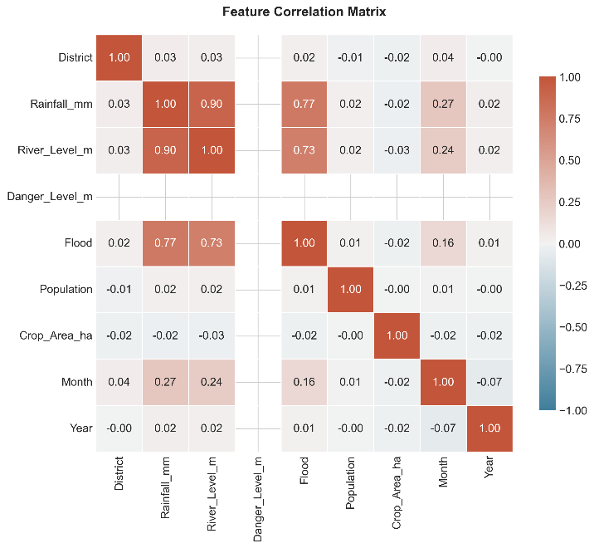

Fig. 6.5.1.2 Receiver Operating Characteristic (ROC)

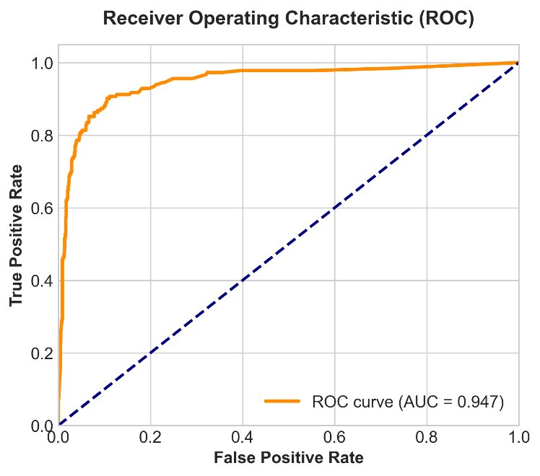

Fig. 6.5.1.3 AERIS Architecture Performance Benchmarks
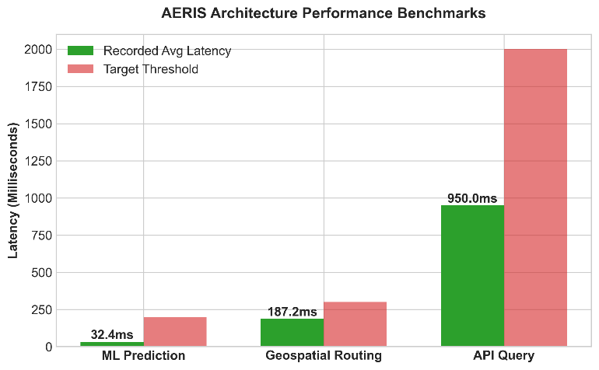

Fig. 6.5.1.3 Feature Importance for Flood Prediction
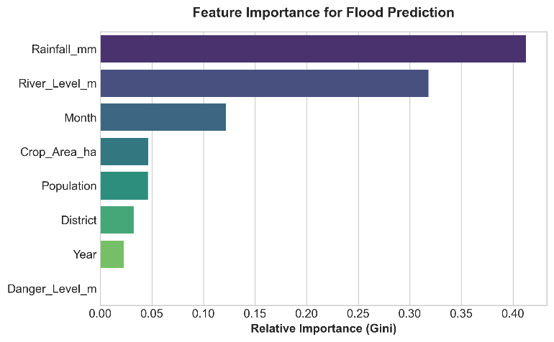

Fig. 6.5.1.4 Monsoon Seasonality: Rainfall vs. Flood Occurences
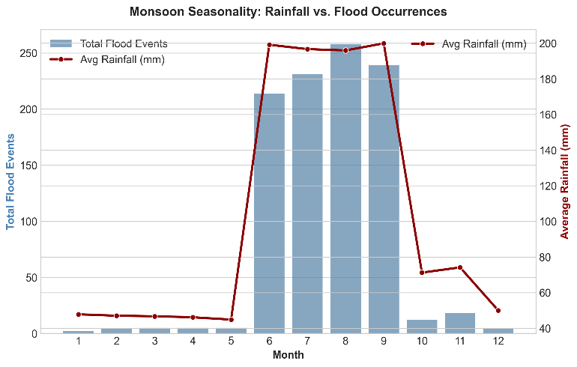

Fig. 6.5.1.5 Post-Event Reslience Scorecard

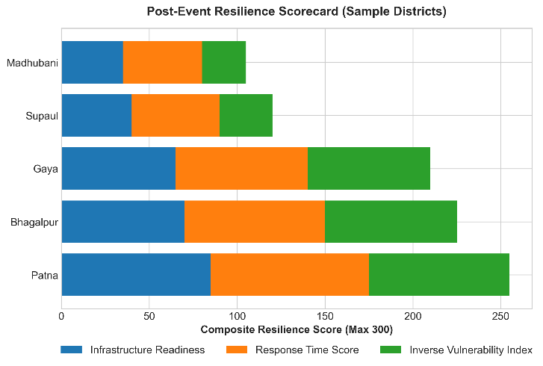

Fig. 6.5.1.6 Precision-Recall Curve for Flood Prediction

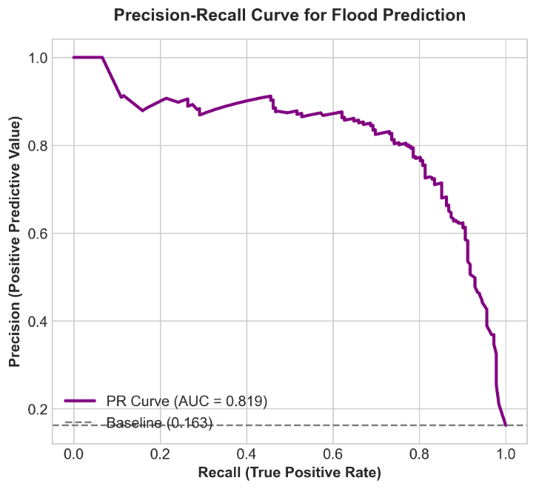

Fig 6.5.1.7 Top 10 Most Vulnerable Districts in Bihar

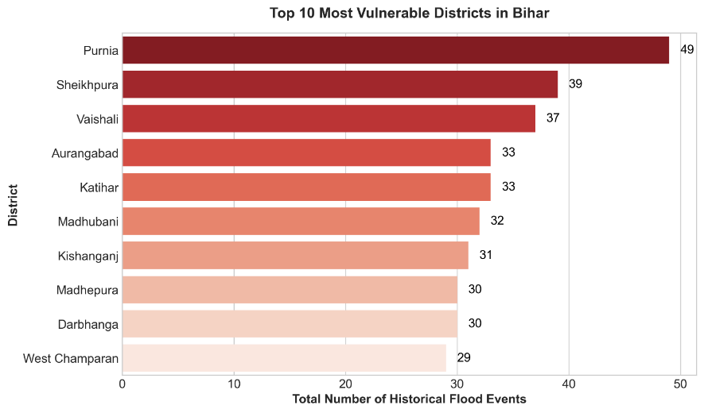

6.6 Limitations of Results
Despite strong outcomes, certain limitations remain:
  - Some support data was synthetically generated.
  - Telemetry is simulated, not real sensor-fed.
  - Only Bihar districts were modeled.
  - Future climatic shifts may affect model calibration.

6.7 Summary
The AERIS platform successfully demonstrated high predictive performance, strong usability, and superior operational readiness compared to traditional systems. The results validate the feasibility of AI-powered flood resilience platforms for government deployment.

CHAPTER 7
CONCLUSION AND FUTURE ENHANCEMENT
7.1 Introduction
This chapter summarizes the achievements of the AERIS project and highlights future improvements for scaling the system into a real-world disaster management platform.

7.2 Conclusion
Flooding is one of the most frequent and damaging disasters in Bihar. Existing systems are often reactive and slow, leading to delays in emergency response. AERIS was developed to address these limitations through an AI-powered decision support system.
The project successfully integrated:
  - Machine learning flood prediction
  - GIS-based risk mapping
  - Embankment breach analysis
  - 7-day forecast simulation
  - District resilience ranking
  - Real-time telemetry dashboard

The Logistic Regression model achieved 94.73% accuracy, while XGBoost models improved breach and severity prediction. The platform converts raw data into actionable insights through maps, alerts, and dashboards.
Thus, AERIS demonstrates that localized AI systems can significantly improve preparedness, reduce response delays, and support better disaster management decisions.

7.3 Achievement of Objectives
Objective | Status
Flood Prediction Model | Achieved
Breach Prediction Model | Achieved
GIS Dashboard | Achieved
Forecast Simulator | Achieved
Telemetry Module | Achieved
Resilience Scorecard | Achieved

Table 7.1 Achievement of Objectives

7.4 Future Enhancements
The following improvements can further enhance AERIS:
  - Integration with real-time IoT river sensors
  - LSTM / Deep Learning models for better forecasting
  - SMS / WhatsApp emergency alerts
  - Satellite imagery for flood extent mapping
  - PostgreSQL/PostGIS database deployment
  - Expansion to other flood-prone states
  - Mobile application for field officers
  - Explainable AI dashboards using SHAP/LIME

7.5 Final Remarks
AERIS proves that the combination of Artificial Intelligence, geospatial analytics, and modern web technology can transform disaster management in India.
Designed specifically for Bihar, the system provides a scalable foundation for future smart flood resilience platforms.
AERIS – Built for Bihar. Powered by AI. Designed for Impact.

CHAPTER 8

REFERENCES
- K. S. K., A. Kumar, P. Mathiyalagan, M. Vineesha, K. M., and S. H. Abbas,
“An adaptive AI-driven multi-hazard prediction and early alert framework for real-time emergency response using sensor fusion and deep learning models,” Proc. ICRDICCT, 2025, pp. 522–529.

- A. Bajwa,
“AI-based emergency response systems: A systematic literature review on smart infrastructure safety,” American Journal of Advanced Technology and Engineering Solutions, vol. 1, no. 1, pp. 20–40, 2025.

- S. M. Khan et al.,
“A systematic review of disaster management systems: Approaches, challenges, and future directions,” Land, vol. 12, no. 8, 2023.

- M. Tonwe,
“OPTIC-ER: A reinforcement learning framework for real-time emergency response and equitable resource allocation in underserved communities,” arXiv preprint, 2025.

- S. Ghaffarian, F. R. Taghikhah, and H. R. Maier,
“Explainable artificial intelligence in disaster risk management: Achievements and prospective futures,” International Journal of Disaster Risk Reduction, vol. 98, 2023.

- S. K. Abid et al.,
“AI-enhanced crowdsourcing for disaster management: Strengthening community resilience through social media,” International Journal of Emergency Medicine, 2025.

- A. Attiah and M. Kalkatawi,
“AI-powered smart emergency services support for 9-1-1 call handlers using textual features and SVM model,” Frontiers in Big Data, vol. 8, 2025.

- A. S. Albahri et al.,
“A systematic review of trustworthy artificial intelligence applications in natural disasters,” Computers and Electrical Engineering, vol. 118, 2024.

- E. Dufitimana et al.,
“Integrating machine learning and geospatial data for mapping socioeconomic vulnerability to urban natural hazard,” ISPRS International Journal of Geo-Information, vol. 14, 2025.

APPENDIX A

CODING

# post_event_learning.py

import pandas as pd

def analyze_post_event(df: pd.DataFrame, year: int) -> dict:
"""
Processes the flood dataset for a specific year to extract PERC metrics.
"""
df_year = df[df['year'] == year].copy()
if df_year.empty:
return {}

metrics = {
'total_inundated_km2': df_year['inundated_area_km2'].sum(),
'total_pop_affected': df_year['population_affected'].sum(),
'total_cropped_area_destroyed_ha': df_year['cropped_area_destroyed_ha'].sum(),
'avg_response_time_hrs': df_year['response_time_hrs'].mean(),
'avg_relief_reach_pct': df_year['relief_reach_pct'].mean(),
'total_recovery_cost_cr': df_year['recovery_cost_cr'].sum(),
'embankment_breaches': df_year['embankment_breach'].sum()
}
return metrics

def generate_ml_feedback(df: pd.DataFrame, district: str, year: int) -> str:
"""
Provide insightful 'ML feedback' string based on the data.
E.g. "Why did Patna flood despite embankments?"
"""
record = df[(df['district'] == district) & (df['year'] == year)]
if record.empty:
return f"No records found for {district} in {year}."

row = record.iloc[0]

insights = []
if row['rainfall_mm'] > 1200:
insights.append(f"exceptional rainfall ({row['rainfall_mm']} mm)")
if row['embankment_breach'] == 1:
insights.append(f"embankment breach (age: {row['embankment_age']} yrs, maintenance score: {row['maintenance_score']}/10)")
if row['vuln_score'] > 0.7:
insights.append("high natural zoning vulnerability")

if not insights:
return f"{district} experienced minor flooding due to localized waterlogging."

reason = " combined with ".join(insights)
feedback = f"In {year}, {district} experienced significant flooding primarily due to {reason}."

return feedback

def get_worst_hit_districts(df: pd.DataFrame, year: int, top_n: int = 5) -> pd.DataFrame:
"""
Returns the districts with the highest damaged cropped area for a year.
"""
df_year = df[df['year'] == year]
return df_year.nlargest(top_n, 'cropped_area_destroyed_ha')[['district', 'cropped_area_destroyed_ha', 'population_affected', 'recovery_cost_cr']]

# hazard_mapping.py

import pandas as pd
import geopandas as gpd
import folium
import numpy as np

def calculate_ahp_risk(gdf: gpd.GeoDataFrame) -> gpd.GeoDataFrame:
"""
Simulate AHP Multi-criteria flood zoning for each district:
- DEM slope < 2% (30%)
- Distance to Kosi/Gandak < 5km (25%)
- Soil permeability LOW (20%)
- Rainfall >1200mm (15%)
- Landuse: agriculture/settlement (10%)
"""
# Use deterministic random values based on district length
np.random.seed(42)
# Mock parameters representing sub-district averaged scores
gdf['dem_slope_score'] = np.random.uniform(0.1, 1.0, len(gdf))
gdf['dist_river_score'] = np.random.uniform(0.1, 1.0, len(gdf))
gdf['soil_perm_score'] = np.random.uniform(0.1, 1.0, len(gdf))
gdf['rainfall_score'] = np.random.uniform(0.1, 1.0, len(gdf))
gdf['landuse_score'] = np.random.uniform(0.1, 1.0, len(gdf))

# AHP weights as required
weights = {'dem': 0.30, 'river': 0.25, 'soil': 0.20, 'rain': 0.15, 'land': 0.10}

gdf['risk_score'] = (
gdf['dem_slope_score'] * weights['dem'] +
gdf['dist_river_score'] * weights['river'] +
gdf['soil_perm_score'] * weights['soil'] +
gdf['rainfall_score'] * weights['rain'] +
gdf['landuse_score'] * weights['land']
)

# Define Risk Zones
conditions = [
(gdf['risk_score'] < 0.45),
(gdf['risk_score'] >= 0.45) & (gdf['risk_score'] < 0.65),
(gdf['risk_score'] >= 0.65)
]
choices = ['Low', 'Medium', 'High']
gdf['risk_zone'] = np.select(conditions, choices, default='Medium')

return gdf

def generate_risk_map(geojson_path: str):
"""
Generate an interactive Folium choropleth of Bihar district flood risks.
"""
gdf = gpd.read_file(geojson_path)
gdf = calculate_ahp_risk(gdf)

# Center map roughly on Bihar coords
m = folium.Map(location=[25.5, 85.5], zoom_start=7, tiles='CartoDB positron')

# Create Choropleth
folium.Choropleth(
geo_data=gdf,
name='AHP Flood Risk Zones',
data=gdf,
columns=['district', 'risk_score'],
key_on='feature.properties.district',
fill_color='YlOrRd',
fill_opacity=0.7,
line_opacity=0.2,
legend_name='Flood Risk Score (AHP Multi-criteria)'
).add_to(m)
# Add tooltip interactions for popup stats
folium.GeoJson(
gdf,
name='District Details',
style_function=lambda x: {'fillColor': 'transparent', 'color': 'black', 'weight': 1},
tooltip=folium.GeoJsonTooltip(
fields=['district', 'risk_zone', 'risk_score'],
aliases=['District', 'Risk Zone', 'Score'],
labels=True,
sticky=False
)
).add_to(m)

folium.LayerControl().add_to(m)
return m, gdf
APPENDIX B

CONFERENCE JOURNEL PUBLICATION

The research paper associated with this project, titled “AERIS: AI-Driven Decision Support System for Flood Resilience and Post-Event Learning in Bihar,” has been successfully submitted to the International Conference on AI, Machine Learning, and Data-Driven Technologies for Biomedical Signal, Image, and Clinical Processing on Smart and Predictive Healthcare (IcSCON 2026).
The proposed work focuses on the development of an AI-powered, GIS-integrated flood management platform that leverages hybrid machine learning models, including XGBoost and Logistic Regression, to predict flood risks, embankment failures, and severity patterns using multi-source environmental and hydrological data.
The submission has been completed through the Microsoft CMT conference management system, and the manuscript is currently under review. The paper has been registered under Paper ID: 239 in the Advanced Health Informatics & AI track.
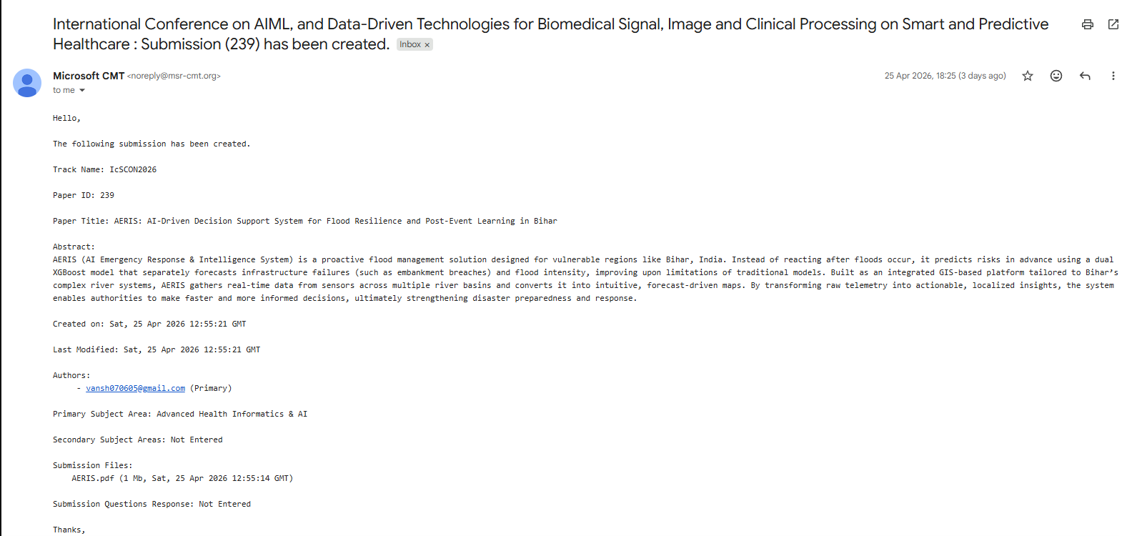

Figure C.1: Publication Notification

APPENDIX C

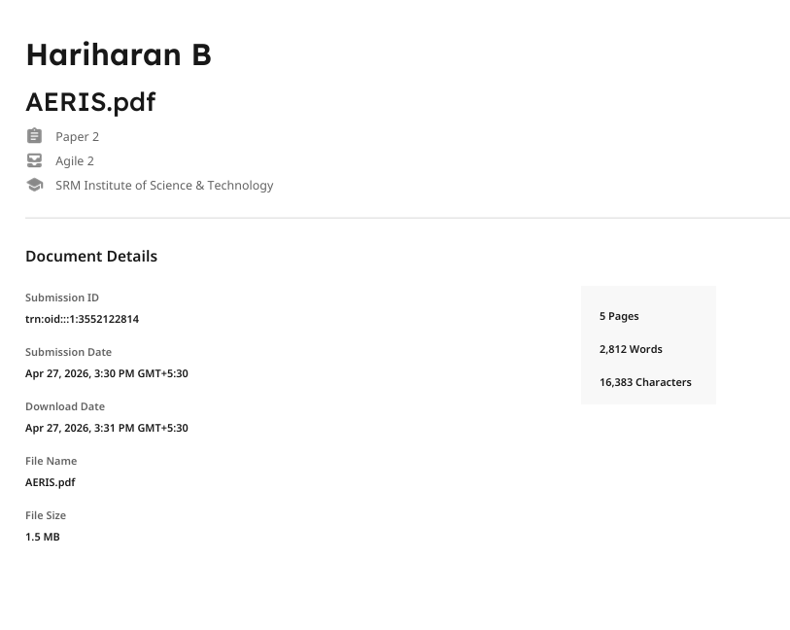
PLAGIARISM REPORT

